 ­

Fast Food Management System

Prof. Ayesha Rashid

Zunair Ahmad: 19011519-015

M. Saqib: 19011519-027

Arooj Saghar: 19011519-037

PROPOSED BY

CS-209

Data Structure and Algorithms

PROJECT

Faculty of Computing and Information Technology

UOG

Contents

Title Page no

Abstract 2

Acknowledgement 2

Introduction 2

Project objective 3

Platform choice 3

Software choice 4

Order Application 5

Database 10

**Abstract**

This report documents include the process of designing, developing and testing a software system to be used in a restaurant; usually given the name “***Fast-Food management system***”. The Fast-Food management system is there to help communication between all teams within a restaurant by minimizing the probability of human errors. This report written by **19011519-(015,027,037)** as part of his 3rd Semester project and was published on Jan 7, 2021.

**Acknowledgements**

I would like to thank my project supervisor, **Prof.Ayesha Rashid**, for providing an awful amount of guidance and input throughout the semester. In addition, I’d like to thank group members for the support and contribution throughout semester at university.

**Introduction**

This gives an introduction to the project by defining the problems encountered by restaurants, the main objectives that the system expects to achieve and a brief introduction to existing solutions.

Even though this approach is implemented in successful profitable restaurants, there are several problems which could be seen as reducing the restaurant’s efficiency:

* Miscommunication caused by handwriting.
* Unmanageable order logging.
* Inefficient restaurant-kitchen communication.
* Difficult order tracking and time management.
* Difficult stock management.
* Limited statistical output.

By introducing an electronic restaurant management system these problems can be avoided or improved leading to an increase in profits.

**Project Objective**

The objective of this project is to build an electronic Fast-Food management system using all of the skills and techniques from the field ensuring that no common development mistakes are reproduced. Project management is critical to all Computer Science projects and keeping to a project plan will be of similar importance. One of the main objectives of any business is to maximize profit by increasing efficiency and decreasing Overhead without compromising customer satisfaction. Currently, many restaurants use a paper-based system to communicate between the restaurant and kitchen which can be shown to be one of the least efficient approaches.

**Platform Choice**

Choosing a suitable platform normally goes down to the programmer’s experience and the type of software to be developed. The restaurant management system could be developed as a web application or a standalone application but must also be widely supported and platform-independent. Therefore as the developer has minimal or no experience in web programming, the decision was taken to develop

a standalone application. The next decision was to decide on a programming language, with the developer having previous experience in C, C++ and Java. This decision was fairly easy and **Java was the selected programming language** as the developer has great knowledge in the Java Database Connectivity (JDBC) API that allows database-independent connectivity between the Java programming language and numerous databases.

**Software Choice**

In software development, the use of integrated development environments (IDE) can increase the efficiency of a programmer. An IDE is a software application that consists of a source code editor, compiler and debugging tools with its main aim to assist the programmer. Simple notepads are not strictly IDEs but can do the same job with the assistance of a compiler.

The two most popular IDEs available for Java programming are Netbeans and Spring Tool Suite Eclipse as they are free, support multiple platforms and offer many features including integrated version control and debugging tools. The two main problems with IDE’s are that due to the wealth of features available and plug-in support, there is an associated cost, as their performance is poor and in particular, they require more memory and processing power than a standard text editor. **For this project Spring Tool Suite was the chosen IDE** as the developer has more experience and knowledge of the Sprig Tool Suite.

**Order Application**

The following annotated screenshots show the functionality of the order application. The screenshotsare ordered to give the reader an idea of the steps involved in order.

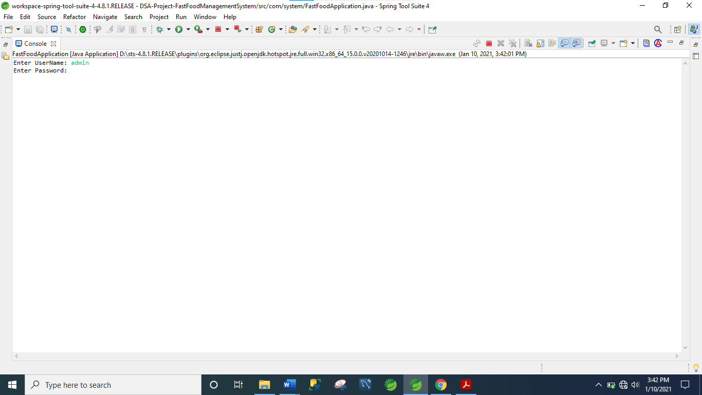

Figure 1: A Screenshot of Admin authentication.

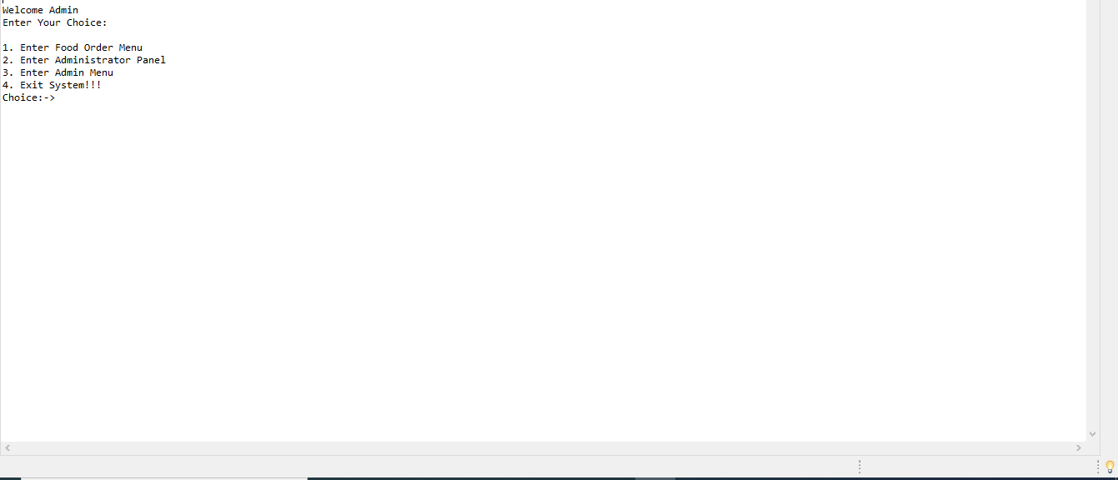 Figure 2: A screenshot of Main Menu

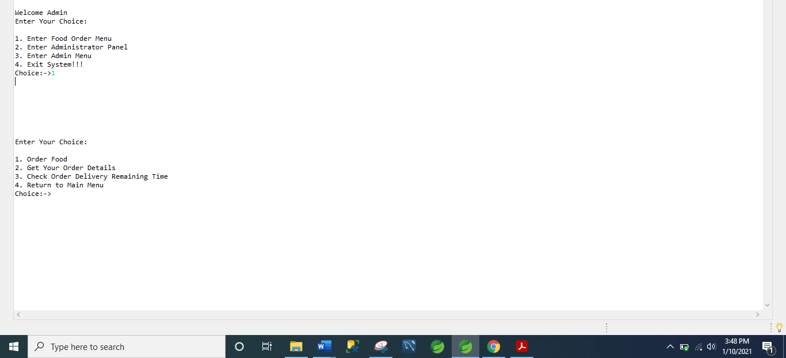Figure 3: A Screenshot of selection 1

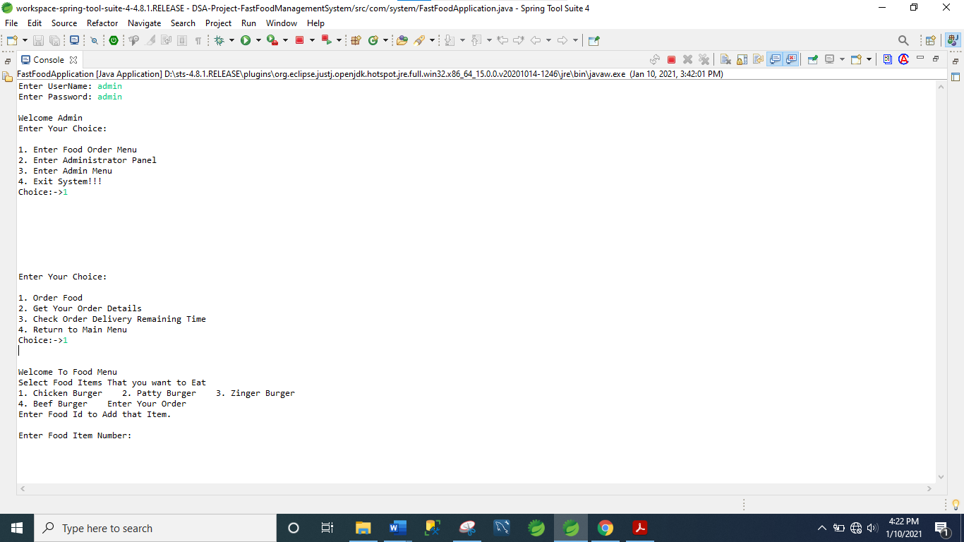

Figure 4: A Screenshot of order Food.

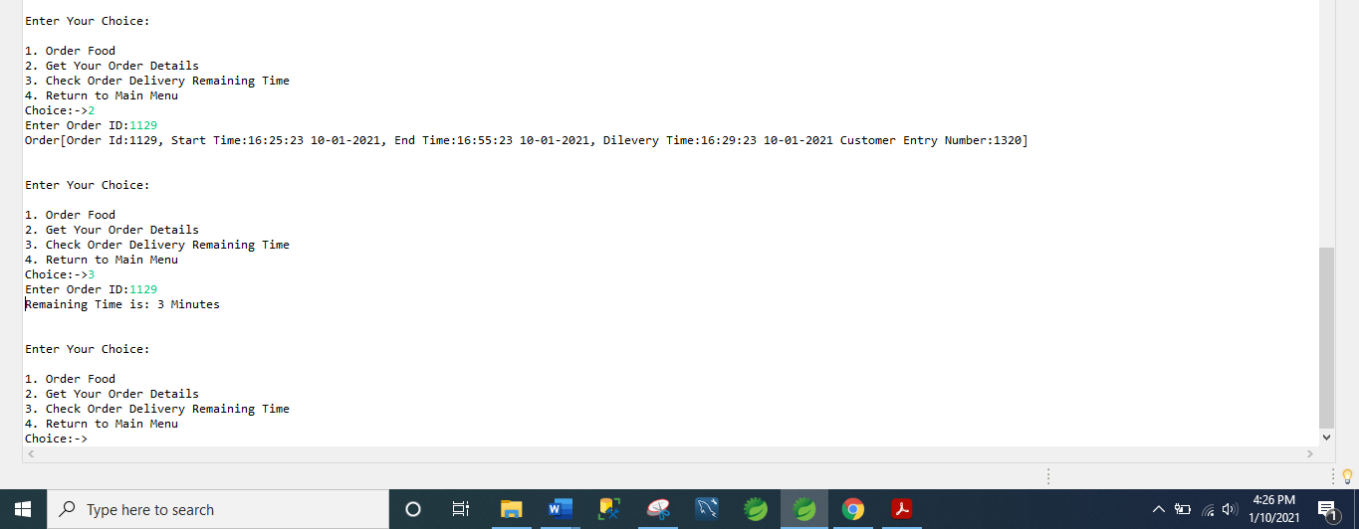Figure 5:A Screenshot showing order details and order delivering time

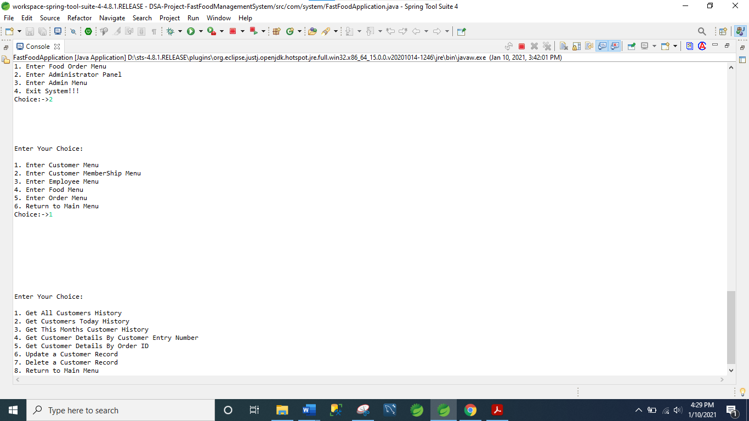

Figure 6: A Screenshot showing all customer menu

This gives the all-customers history, today’s history and monthly history.it will show the customer details by the entry number and order ID respectively. Gives the facility to update and delete record of Customer.

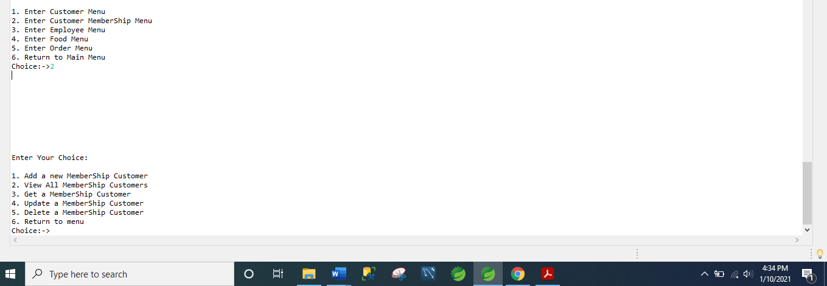

Figure 7: A screenshot of Customer Membership menu

It will give the facility to add new membership ,view all membership, to get the membership of customer, update and delete membership of customer.

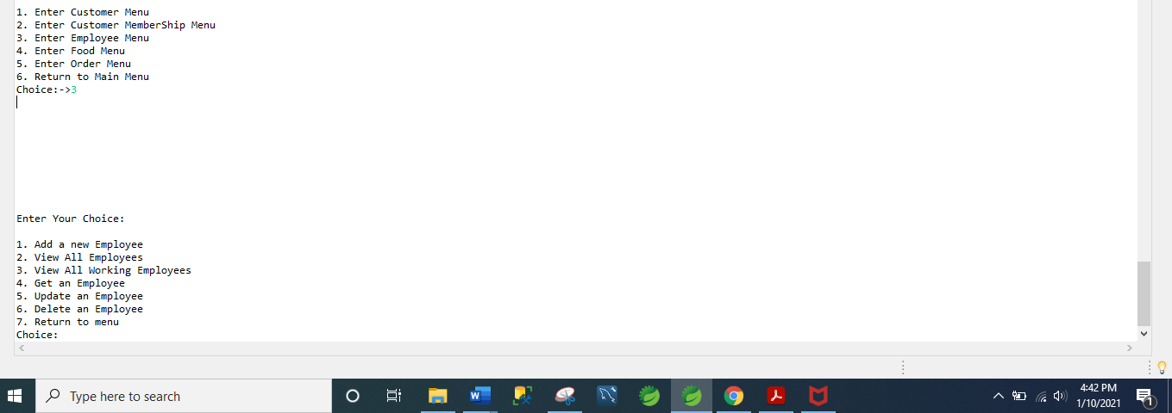Figure 8: A screenshot of Employee menu

It will get, add, update, delete and view all employee and the working employee.

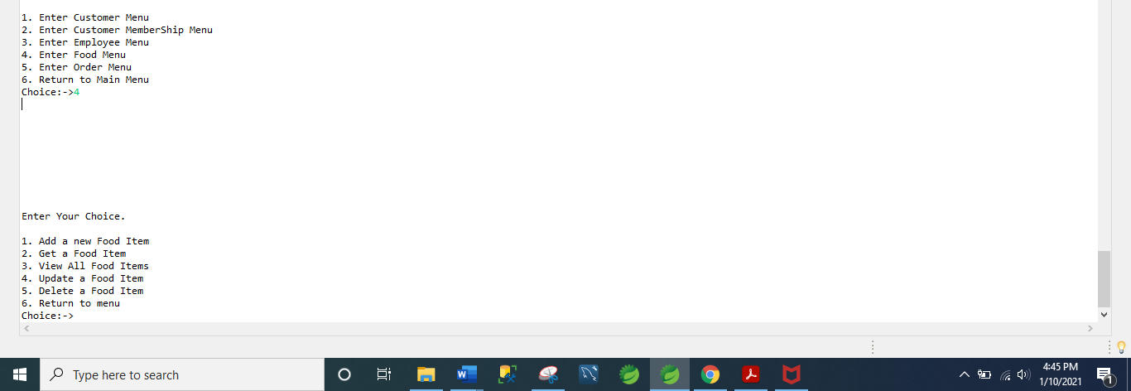Figure 9: A screenshot of food menu

It will add, get, update, Delete and view all food item.

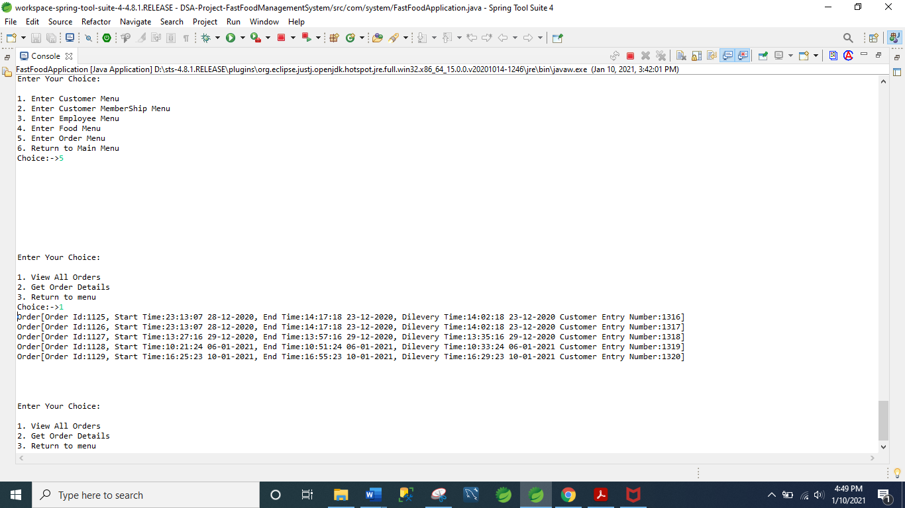

Figure 10: A screenshot of Order menu.

It will provide the facility to get and view order details.

**Database**

Database is used in order to store records and data. There are various database available in order to store data in it like SQL server, MySQL and MariaDB etc. We have used MySQL as database management.

Following Pictures will illustrate the working

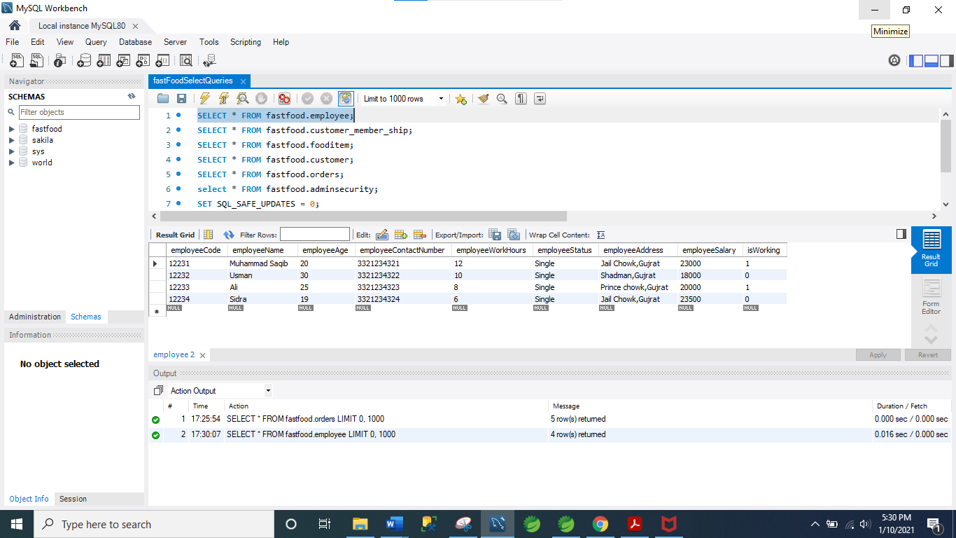

Figure 1: A screenshot of Employee data

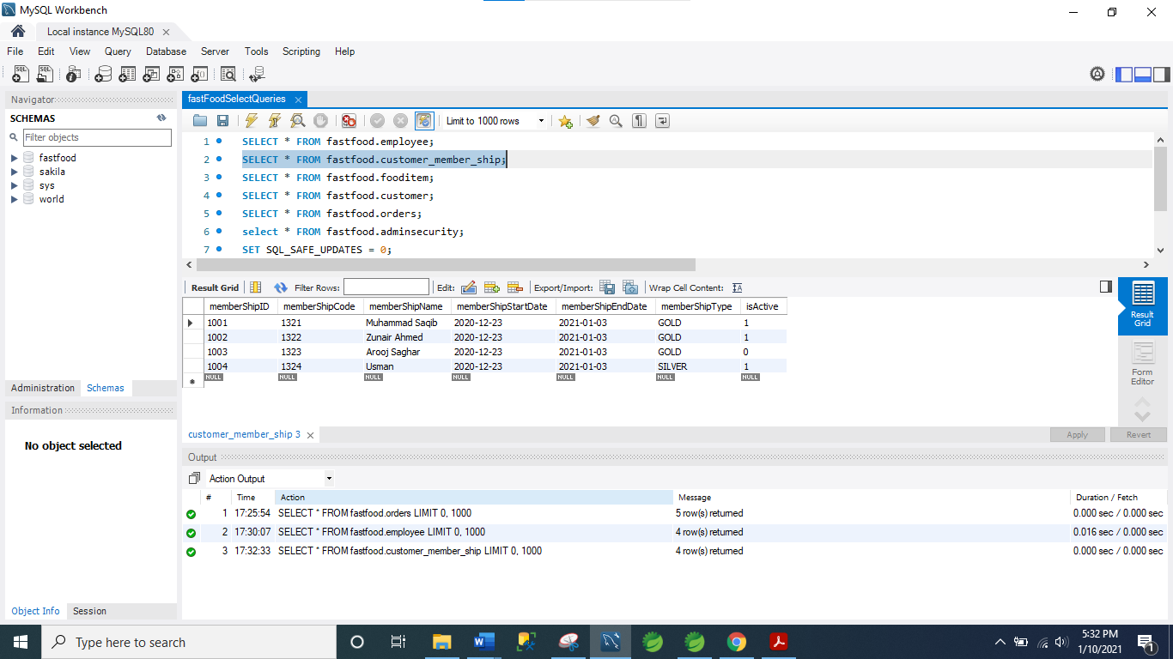

Figure 2: A Screenshot of Customer Membership.

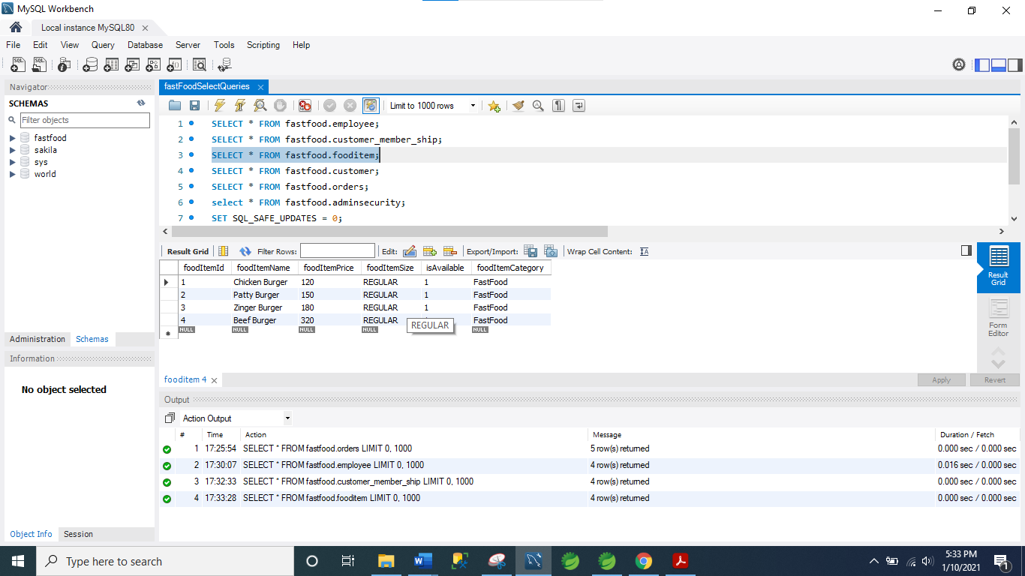

Figure 3: A Screenshot of Food Items.

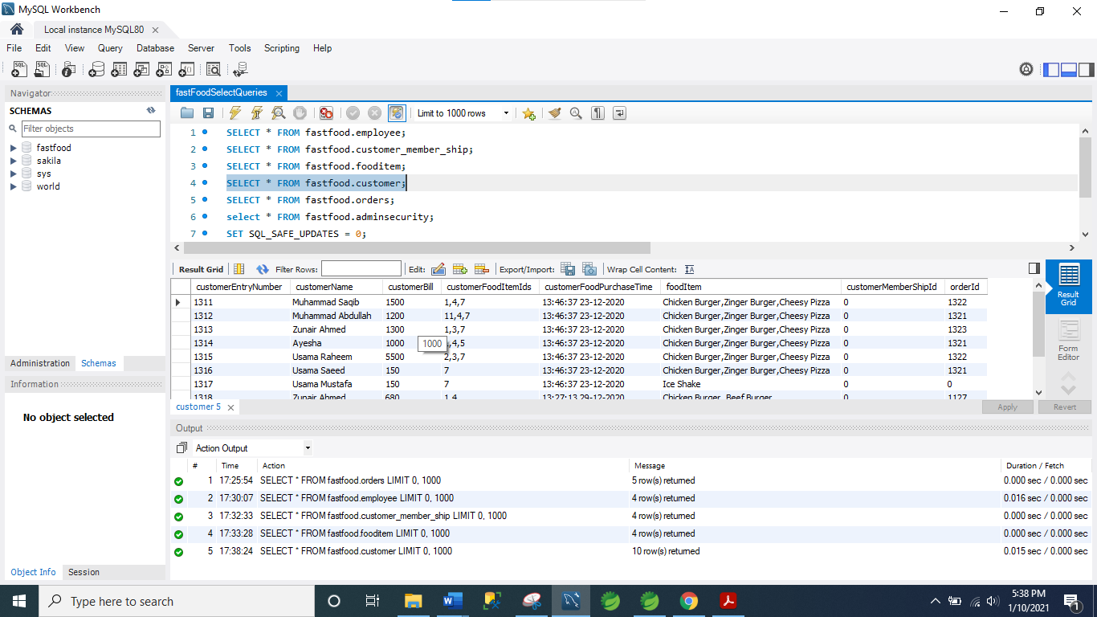

Figure 4: A screenshot of Customers

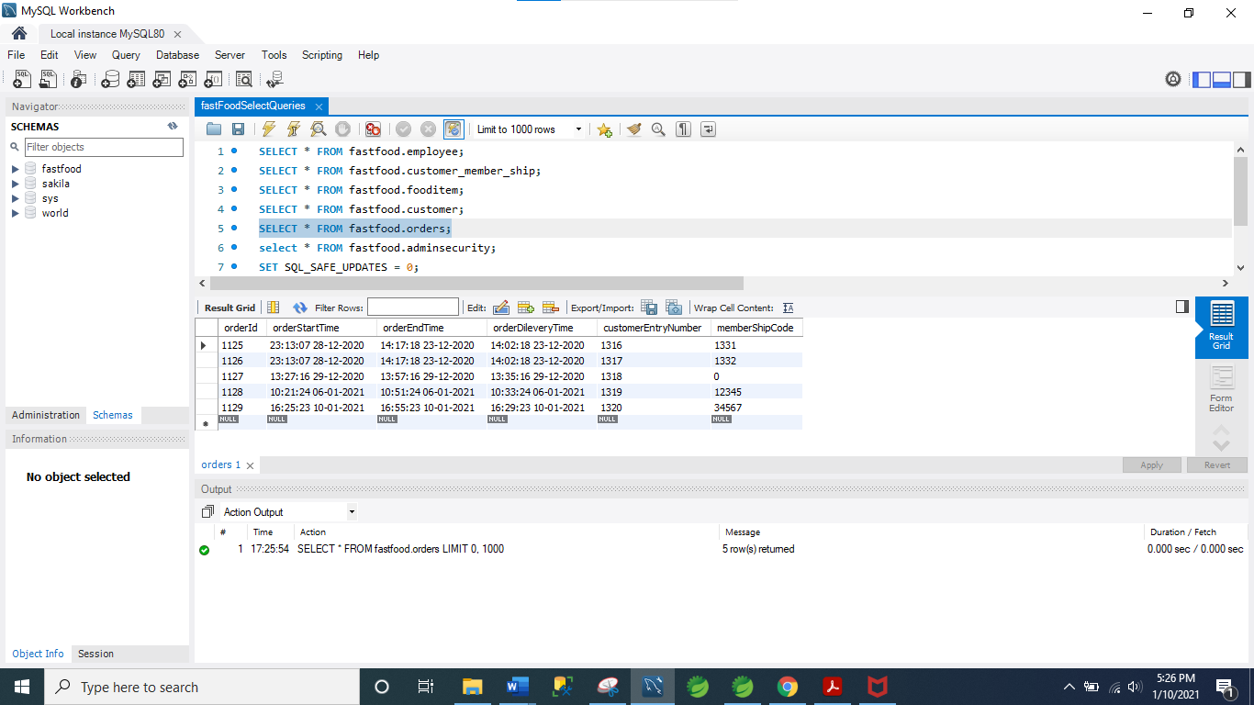Figure 5 : A screenshot of orders

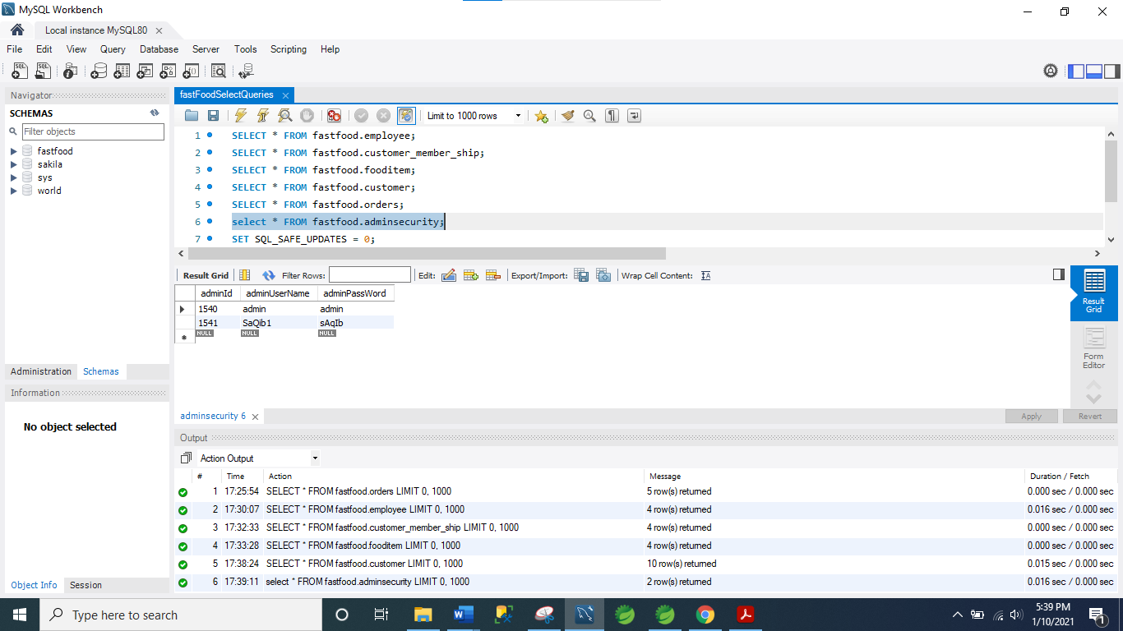Figure 6: A screenshot of Administration.

**Appendix A**

**Initial Project Plan**

For my third semester project we have to design a Fast Food management system. This will involve designing a system for the customer, Food item, and employee.

**A.1 Aims & Objectives**

The aims of the restaurant management system will be to:-

* Increase efficiency of the restaurant by decreasing process time. This will speed up table turning which will result in an increase in profit.
* Simplify communication between the customer and staff. All orders taken by the staff
* Ease of setup for the end user – adding, costs, menus etc to the system.
* Ease of figure generating: revenue, turnover, profit, and operating costs.
* Design a user friendly whilst still allowing all combinations of options and extras for every meal.

**A.2 Proposed System Features**

The proposed system features can be split into two categories:

essential features and wish-list.

The essential features :-

* The system will require a very simple user Friendly
* menu is a necessity. Advanced options incorporated into the simple front
* end to reduce the potential limitations. Allow options for every meal that can
* be added at an extra cost.
* User credentials to track the transaction history and average table turning time of every member in the team.
* 4.MY SQL /Oracle relational database to hold all the courses
* Administrator options for voiding and applying discounts
* Management features for viewing sales report, costing etc.
* Booking tool for allocating tables with table turn estimation.

The wish-list:-

* Bluetooth PDA’s for the restaurant staff so the orders will be immediately sent to the kitchen staff decreasing process time.
* Graphical user Interface.
* User training built into the system.
* Table management map – Easy allocation of staff to tables and the progress of the current customers.

**A.3 Deliverable Summary**

At the first 6th week we presented the proposal of the project and explain all the modules and working of project.

The second deliverable phase start at the beginning of 12th week. we presented all the working of 50% evaluation of the project. Obviously, there could be some design tweaks whilst in the implementation or testing stage and this have to be accommodated when the issue arises.

The third implementation phase started at second last week of semester. In the final deliverable week,we presented full working project. we have thoroughly described all the working of our management system.